**OUTREACH ACTIVITY 2023-24**

**THANAL SCHOOL VISIT 04-08-2023**

On 4th August 2023, the second-year students of Kannur Salafi B.Ed. College visited Thanal School for the Disabled as part of their teaching practice program. This visit was an enriching experience designed to help future educators understand the principles and practices of inclusive education. From the moment the students arrived, they were warmly welcomed by the school’s staff and administration, who introduced them to the school’s mission of fostering an environment where differently-abled children could thrive academically, socially, and emotionally.The day began with an orientation session led by the principal and staff, who provided an overview of the school’s approach to inclusive education. The visitors were given insights into how the institution tailors its teaching methods to cater to the individual needs of each child. The dedication to equality and inclusivity was evident in every aspect of the school’s functioning, from its curriculum design to the integration of therapeutic support.

During the visit, the B.Ed. students had the opportunity to observe and participate in various activities. The trained staff demonstrated the use of assistive technologies such as speech-to-text devices, sensory boards, and braille tools that help bridge communication gaps for students with disabilities. The visitors were also introduced to Individualized Education Plans (IEPs), which outline customized learning objectives and strategies for each child based on their unique strengths and challenges.The integration of therapeutic interventions into the daily routine of students was another standout feature of the visit. The students observed occupational therapy, speech therapy, and physiotherapy sessions, which were seamlessly woven into the educational framework to promote holistic development. These demonstrations highlighted the importance of addressing physical and cognitive needs alongside academic learning.

Interactive sessions added a personal dimension to the experience. The B.Ed. students engaged with the children through storytelling, sensory-based learning activities, and games aimed at improving motor and cognitive skills. This interaction provided a firsthand understanding of the children’s capabilities, resilience, and enthusiasm for learning. It also underscored the importance of patience, empathy, and creativity in creating an inclusive classroom environment.The visit to Thanal School left a lasting impression on the B.Ed. students. It was not just a learning experience but an inspiration that emphasized the transformative power of inclusive education. The students realized the significance of collaboration among teachers, therapists, and parents in fostering an environment where all children can succeed. They also recognized the value of adaptability and innovation in teaching methods to meet the diverse needs of learners.This visit broadened the perspectives of the aspiring educators, shifting their focus from traditional teaching methods to a more inclusive approach that values every student’s potential. It reinforced the idea that education is not just about imparting knowledge but about creating opportunities for every child to thrive, regardless of their abilities.

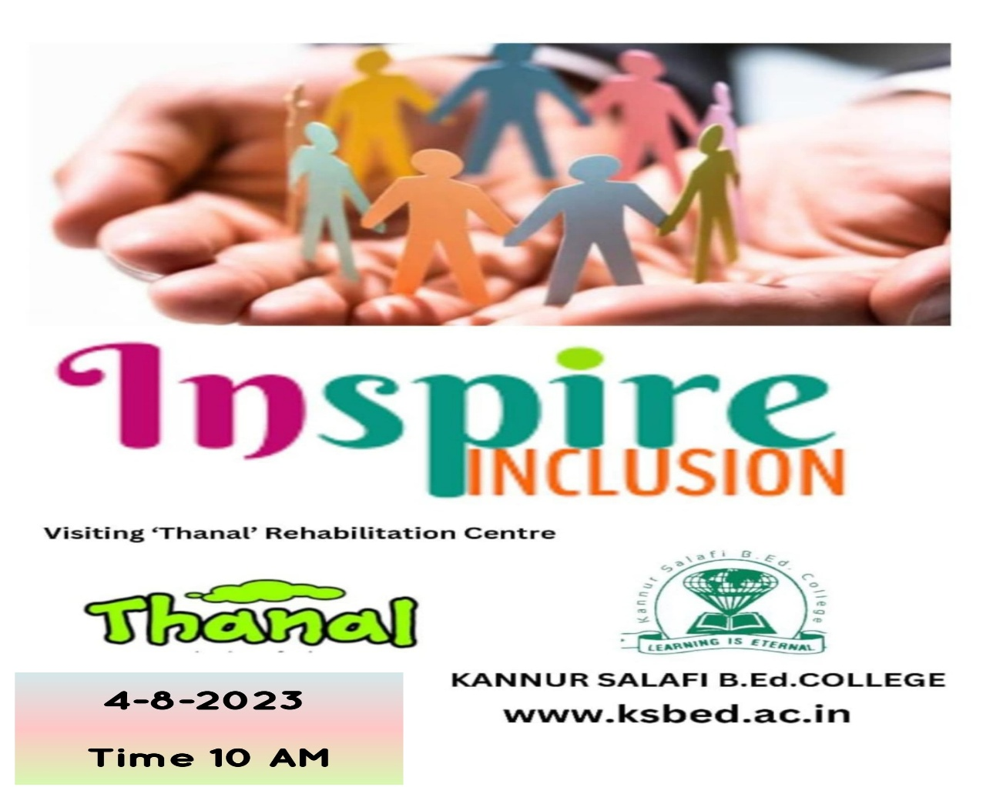THANAL SCHOOL VISIT ON 04-08-2023

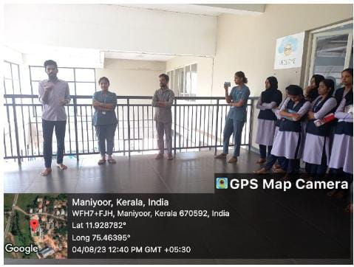

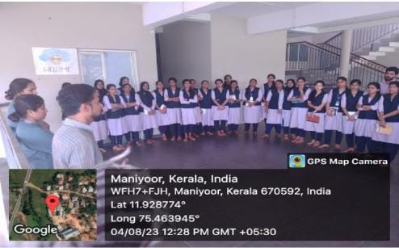

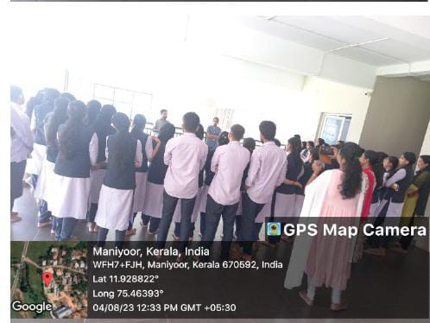

**FARMERS DAY CELEBRATION 18-08-2023**

Kannur Salafi B.Ed. College organized a memorable Farmers' Day celebration on 18th August 2023 at the renowned Kuttiattoor Mango Factory. The event aimed to honor the invaluable contributions of farmers and provide students with insights into the agricultural sector and its associated industries. It was a day filled with inspiration, learning, and appreciation for those who work tirelessly to feed the nation.The highlight of the event was the honoring of two dedicated farmers who have significantly contributed to the agricultural landscape of the region. These farmers shared their experiences, recounting their journeys, challenges, and achievements in farming. Their stories resonated deeply with the audience, offering valuable lessons on resilience, innovation, and the importance of sustainable agricultural practices. The college principal, Dr. Naseerali MK, presented them with tokens of appreciation, acknowledging their hard work and dedication.

The event also included a guided visit to the Kuttiattoor Mango Factory. Students and staff explored the facility, gaining firsthand knowledge about the processes involved in mango production, preservation, and product manufacturing. The factory tour was both educational and engaging, as participants observed the transformation of fresh mangoes into a variety of products. The experience shed light on the critical link between agriculture and industries, emphasizing the value of collaboration in creating high-quality goods.At the conclusion of the visit, students and staff purchased mango-based products from the factory, taking home not only delicious treats but also a deeper appreciation for the efforts behind them. The interaction with the farmers and the exposure to the production process provided a holistic understanding of the agricultural ecosystem, making the day a truly enriching experience.

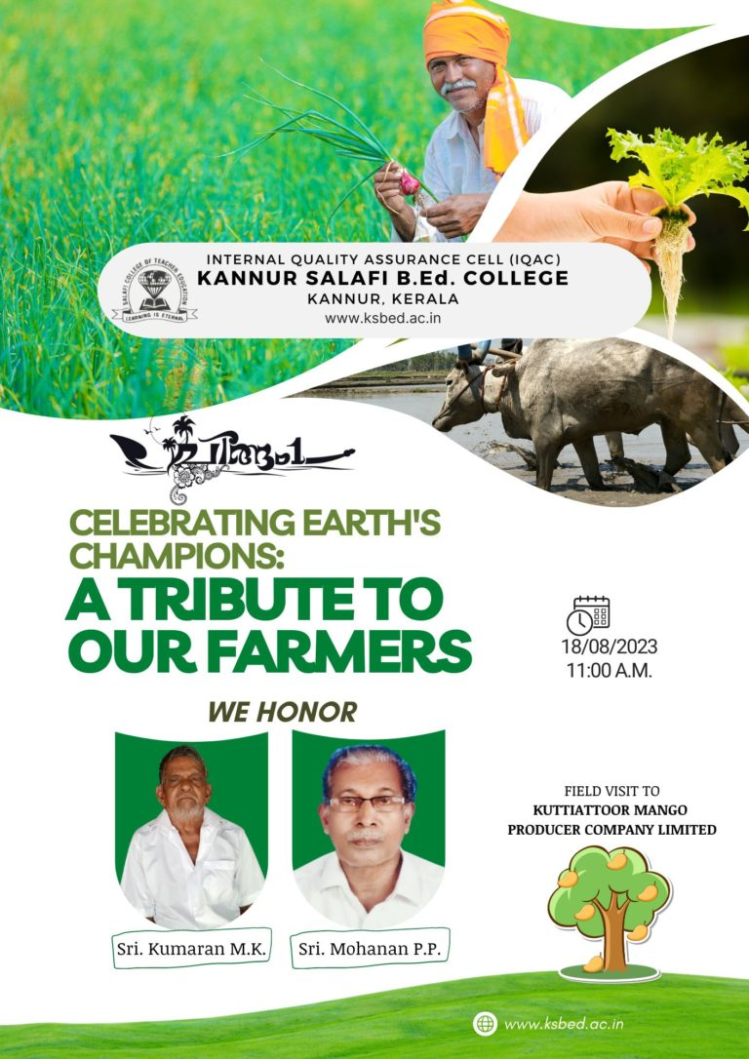The Farmers' Day celebration at Kuttiattoor Mango Factory was a wonderful initiative by Kannur Salafi B.Ed. College to bridge the gap between education and practical exposure. It fostered respect for farmers, highlighted the importance of agriculture, and inspired the students to appreciate the hard work that goes into producing the food we consume. The event was a blend of learning, gratitude, and enjoyment, leaving a lasting impression on everyone who participated.

FARMERS DAY ON 18-08-2023

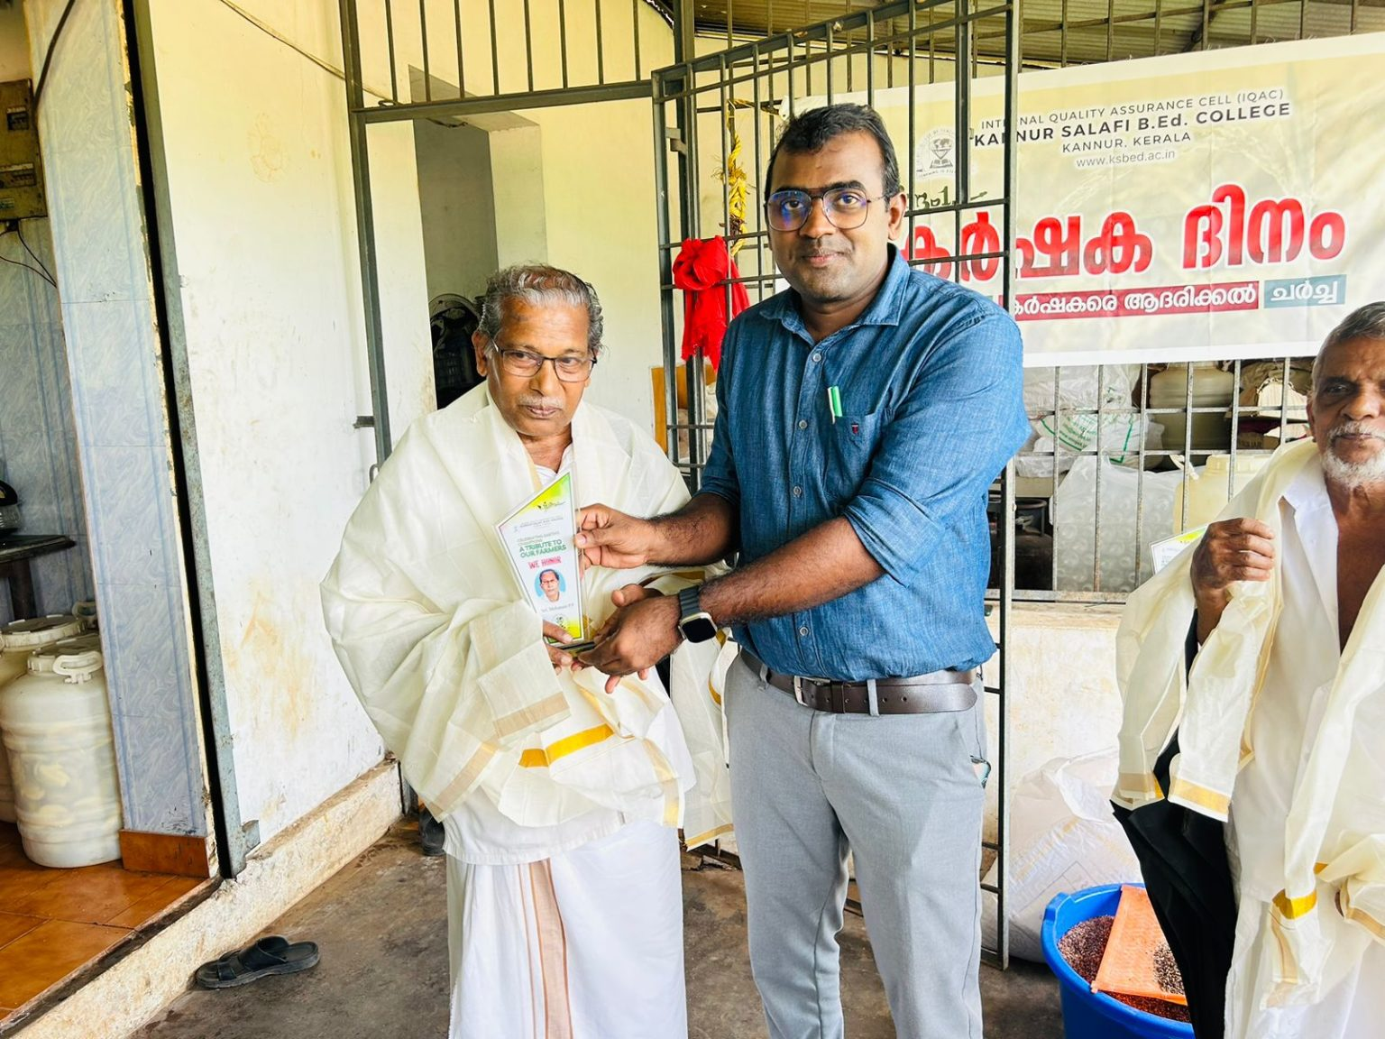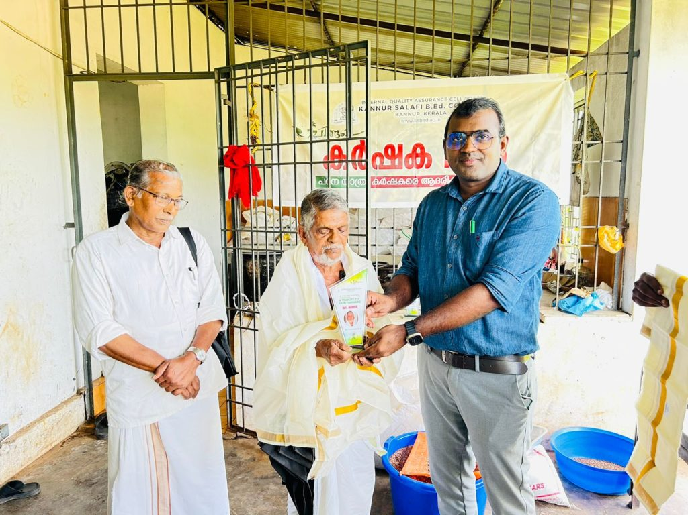

**FIRST AID AWARENESS CLASS 25-01-2024**

On 4th October 2023, Kannur Salafi B.Ed. College organized a First Aid Awareness Class that brought together students and members of the local community. The event aimed to educate participants on the importance of first aid and equip them with essential skills to respond effectively in emergencies. The class was led by Ms. Shifa, the Head Nurse at Kuttiattoor Panchayath Community Health Center, whose expertise and engaging teaching style made the session both informative and interactive. The awareness class covered a range of topics, including how to assess and manage injuries, provide CPR, handle choking incidents, and respond to medical emergencies such as burns and fractures. Ms. Shifa explained each concept with clarity, ensuring that participants of all age groups could easily understand and retain the information. Emphasis was placed on the critical role of first aid in saving lives and minimizing the impact of injuries before professional medical help arrives.

A highlight of the session was the demonstration segment, where participants witnessed practical applications of first aid techniques. Ms. Shifa, along with her team, demonstrated step-by-step procedures for CPR, dressing wounds, and handling sprains and fractures. Participants were also given opportunities to practice these techniques under her guidance, making the session highly interactive and engaging. The hands-on experience helped build confidence among the attendees, empowering them to act decisively during emergencies.The class was well-received by both the students and the community members, who appreciated the college’s initiative in organizing such a relevant and practical event. Many participants expressed their gratitude for the opportunity to learn life-saving skills, noting how the knowledge gained could make a significant difference in critical situations.

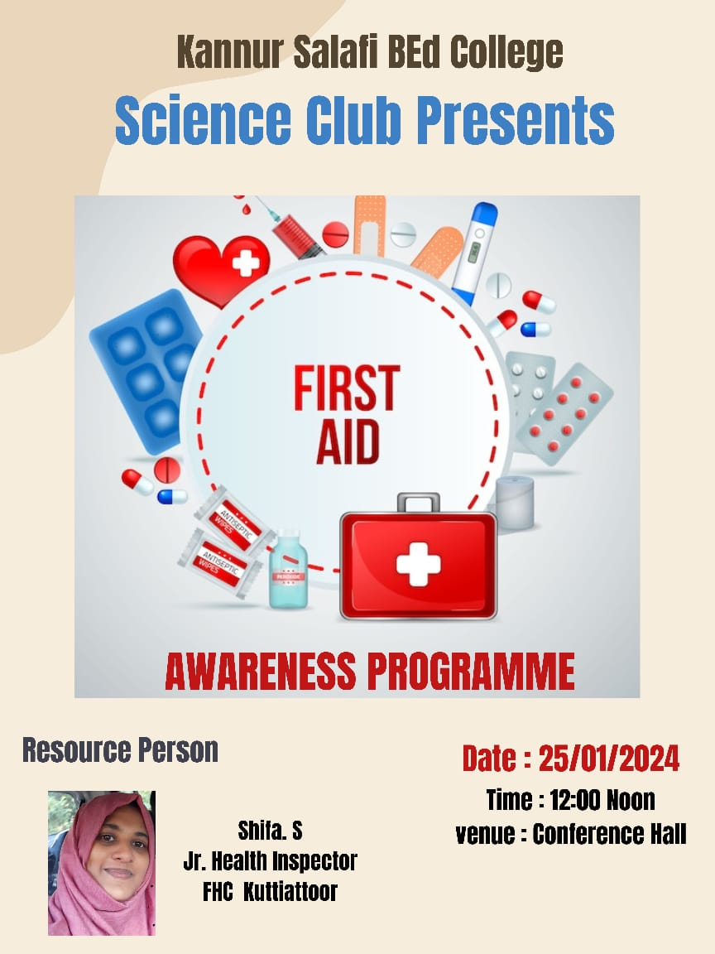The First Aid Awareness Class was a wonderful experience that not only enhanced the knowledge and preparedness of the participants but also strengthened the bond between the college and the local community. The event underscored the importance of collaboration in promoting health and safety, leaving a lasting impact on everyone involved. It served as a reminder that first aid is not just a skill but a responsibility that can empower individuals to save lives and support one another in times of need.

FIRST AID AWARENESS CLASS 04-10-2023

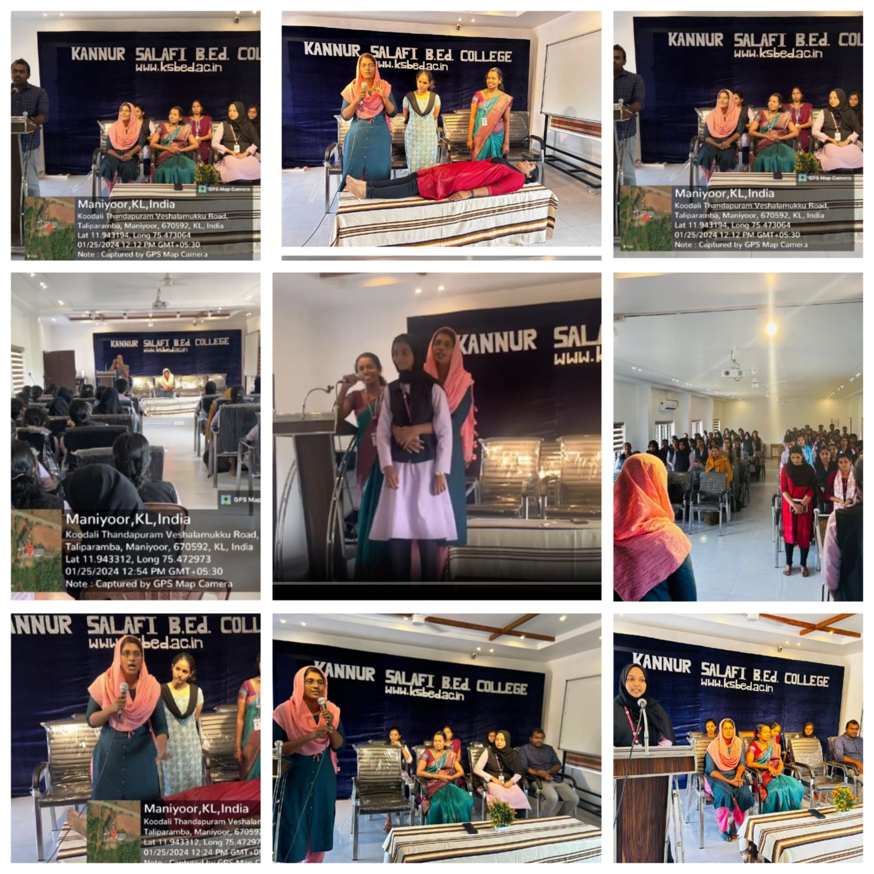

**SUB DISTRICT SPORTS AT IMNSGHSS,MAYYIL 08,09 OCTOBER 2023**

On the 8th and 9th of October 2023, the students of Kannur Salafi B.Ed. College actively participated in the Sub District Sports event held at IMNSGHSS, Mayyil. The event brought together young athletes from various schools, creating an atmosphere of excitement, competition, and camaraderie. The involvement of the B.Ed. students as helping volunteers added significant value to the event's smooth execution and organization.The students took on a range of responsibilities with dedication and enthusiasm. They played a key role in managing food distribution, ensuring that participants, coaches, and officials were provided with timely and sufficient refreshments. Their efficiency and teamwork helped in maintaining order and ensuring that everyone involved in the event was well cared for throughout the day.

Another significant contribution by the students was in handling certificate writing, a task that required attention to detail and precision. By efficiently preparing and organizing the certificates for distribution, they ensured that the deserving athletes were recognized for their achievements in a timely manner. Their efforts reflected a high level of responsibility and commitment to the success of the event.Apart from these specific tasks, the students were also actively involved in other support activities, assisting the event organizers in various capacities. Their willingness to contribute wherever needed and their ability to adapt to different roles demonstrated their teamwork and problem-solving skills. Their active participation not only helped in the smooth functioning of the event but also set an example of community service and collaboration.

The experience of participating in the Sub District Sports was a rewarding one for the students of Kannur Salafi B.Ed. College. It provided them with an opportunity to engage with the local community, support young athletes, and contribute to the success of a large-scale event. This experience also helped them develop organizational skills, teamwork, and a sense of social responsibility, which are essential qualities for future educators.The Sub District Sports at IMNSGHSS, Mayyil, was not just a platform for athletic excellence but also a celebration of community and collaboration. The active involvement of Kannur Salafi B.Ed. College students exemplified the spirit of volunteerism and highlighted the importance of contributing to initiatives that bring people together. Their efforts left a positive impression on everyone involved, making the event a memorable experience for all.

SUB DISTRICT SPORTS AT IMNSGHSS,MAYYIL 8,9-10-2024

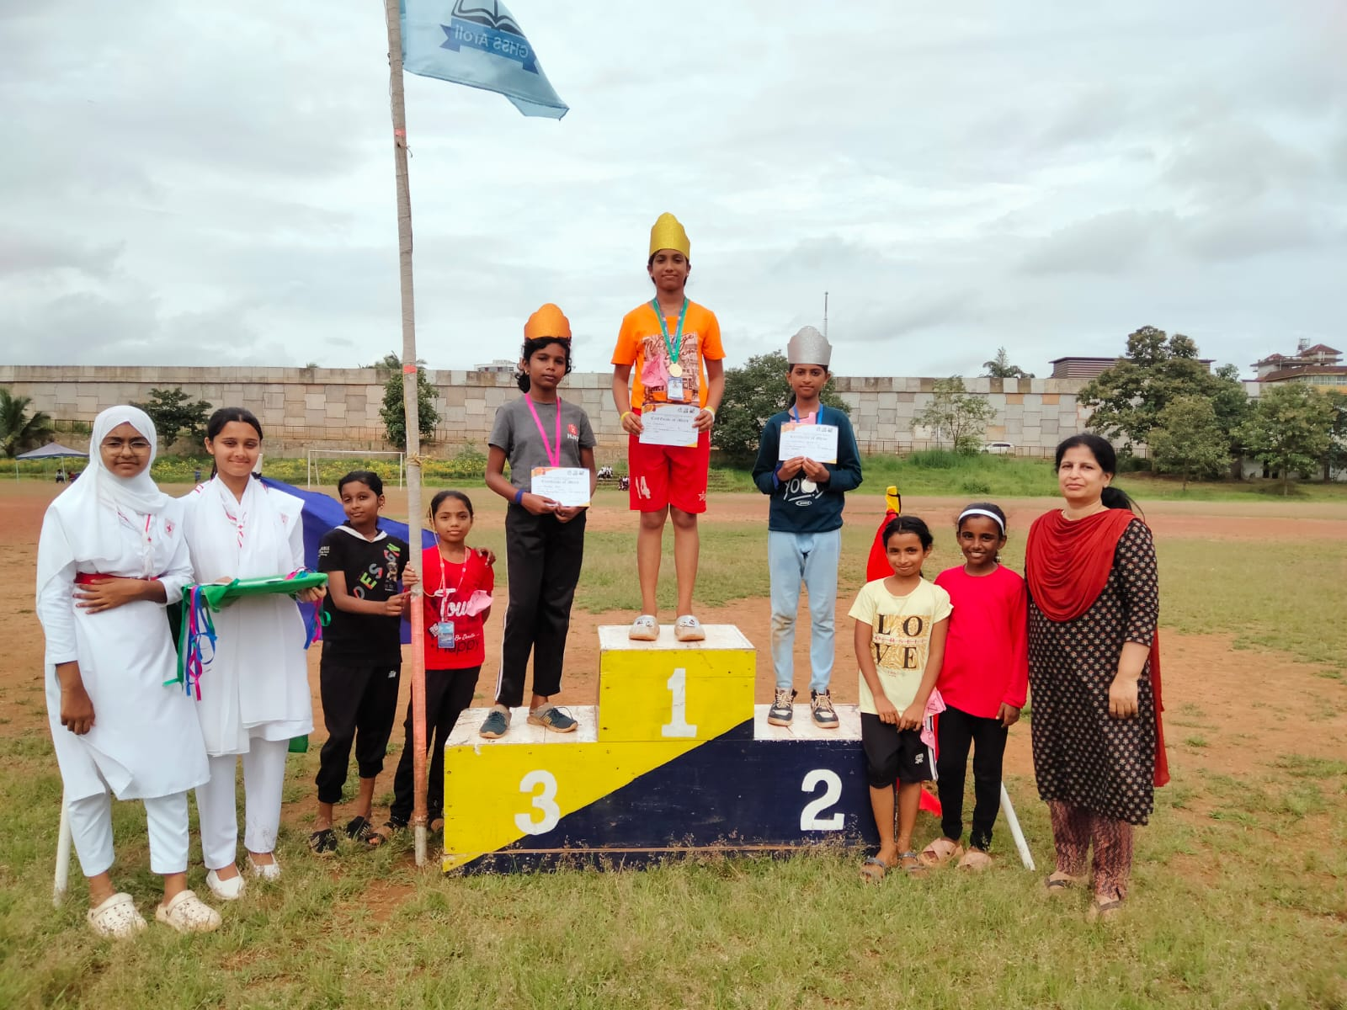

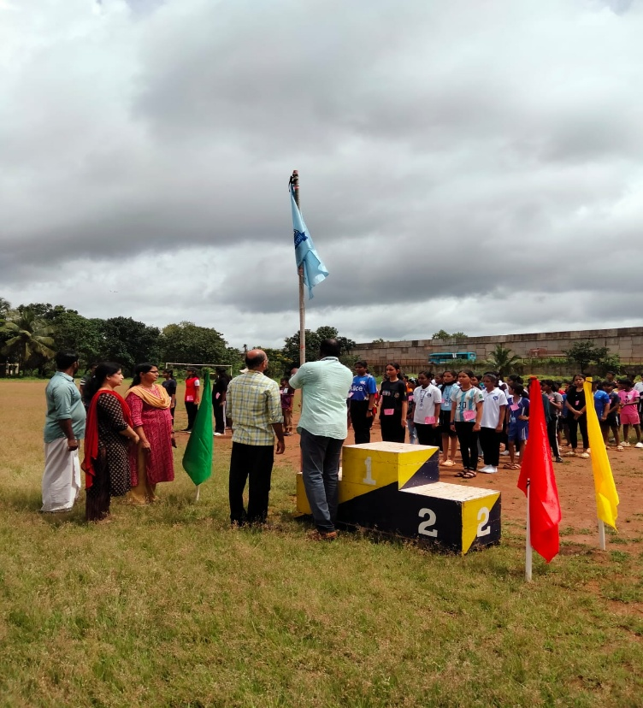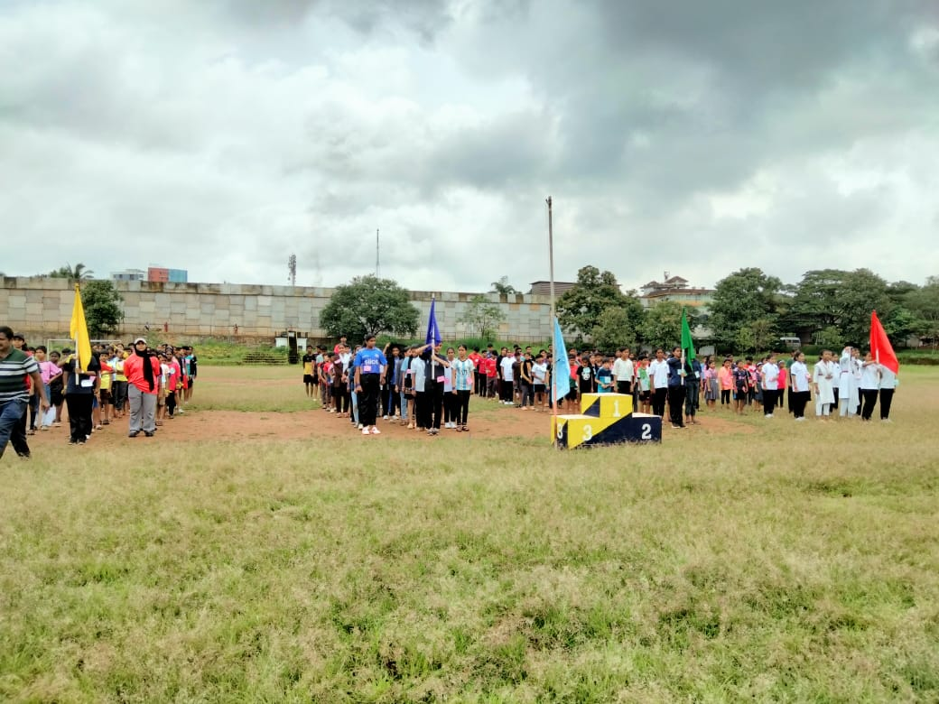

**SHASTRAMELA GHSSCHATTUKAPPARA , 24 TO 26 OCTOBER 2023**

From 24th to 26th October 2023, the students of Kannur Salafi B.Ed. College actively participated as helping volunteers in the Shastramela held at Chattukappara GHSS. The event, which brought together a large number of participants, was a platform for showcasing talent, promoting learning, and fostering community spirit. The students from Kannur Salafi B.Ed. College played a pivotal role in ensuring the smooth conduct of the event, contributing to its success in a variety of ways.One of the primary responsibilities undertaken by the students was food distribution. They efficiently managed the distribution of meals to participants, organizers, and volunteers, ensuring that everyone had access to timely and nutritious food. The students worked diligently, maintaining an organized and timely service that allowed the event to proceed smoothly without any interruptions.

In addition to food distribution, the students were involved in certificate writing, preparing the recognition certificates for participants who excelled in various activities. Their attention to detail and commitment to accuracy ensured that every deserving individual received their certificate promptly. By handling such tasks, the students demonstrated a high level of responsibility and a keen eye for organization.Beyond these specific roles, the students of Kannur Salafi B.Ed. College also assisted with various other support activities, including setting up the venue, helping participants with their requirements, and offering general assistance wherever needed. Their enthusiasm, teamwork, and willingness to contribute in multiple capacities highlighted their dedication to the success of the event.

The Shastramela at Chattukappara GHSS provided a valuable opportunity for the students to develop essential skills such as teamwork, organization, and community engagement. By participating as volunteers, they gained a deeper understanding of the importance of collaboration and service in the success of large events. This experience not only enhanced their personal growth but also reinforced the significance of volunteering and community involvement in education.Overall, the participation of Kannur Salafi B.Ed. College students in the Shastramela was a meaningful and rewarding experience. Their contributions helped make the event a resounding success, and they left with a sense of accomplishment, having made a positive impact on the community and the participants of the event.

SHASTRAMELA AT GHSS CHATTUKAPPARA 24 TO 26 OCTOBER

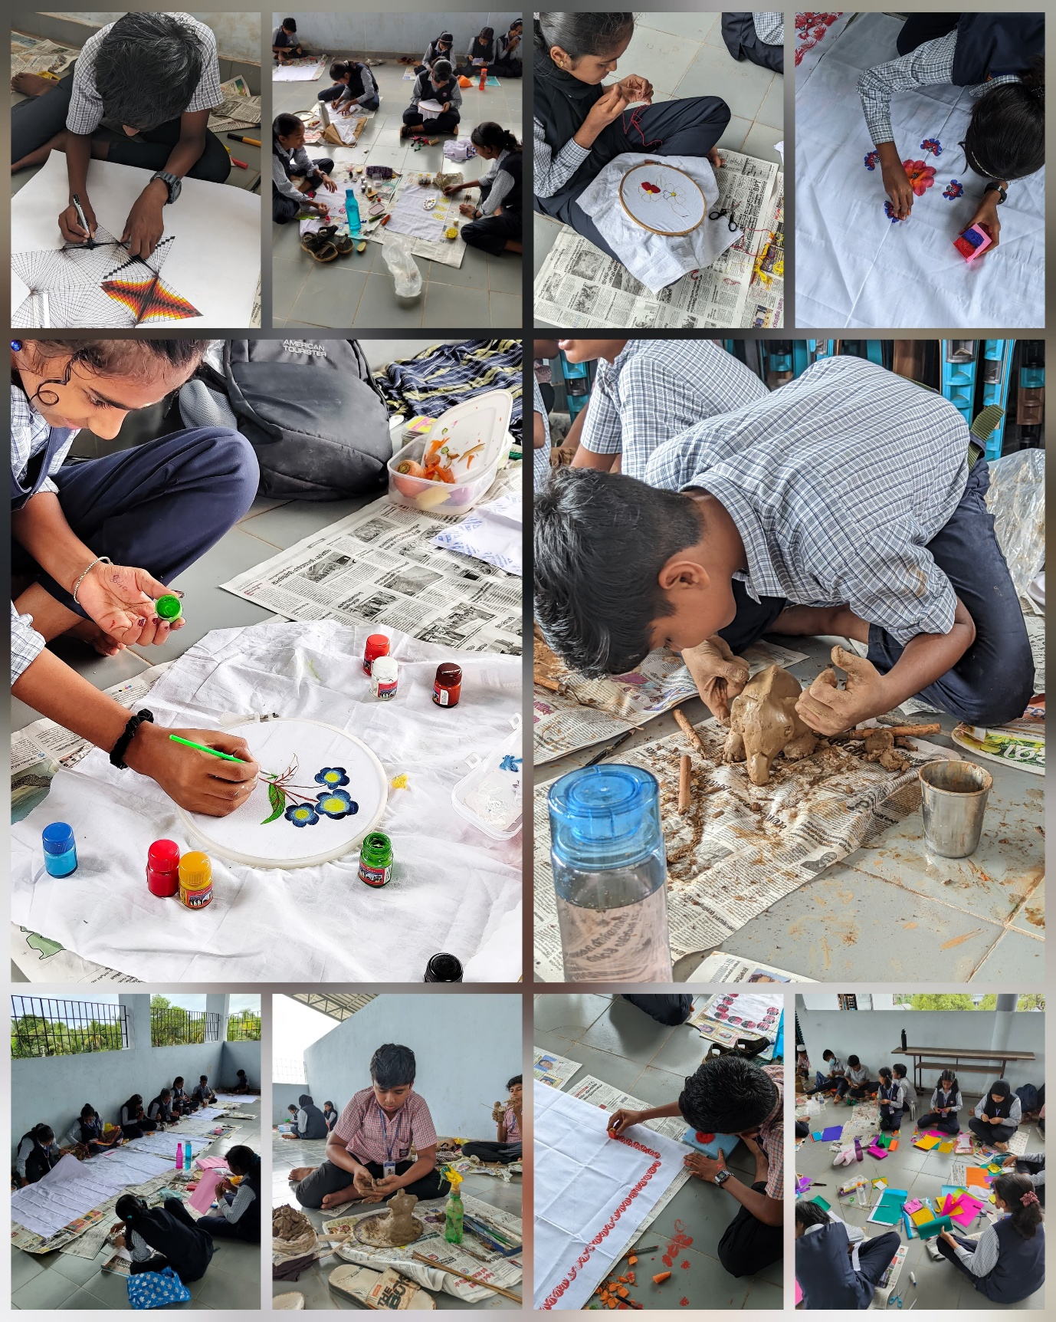

**CHILDRENS DAY CELEBRATION AT CHITRARI ASHA SCHOOL 14-11-2023**

On 14th November 2023, the first-year students of Kannur Salafi B Ed College had the privilege of celebrating National Children's Day at Chitrari Asha School, a place that brings together the spirit of innocence and hope. The day was a heartwarming and unforgettable experience spent in the company of the specially abled children of the school, who welcomed their guests with open arms and bright smiles. The morning unfolded as a celebration of joy, inclusion, and love.The event began with an inaugural address by Ms. Sreekala, a faculty member at Chitrari Asha School, who eloquently introduced the institution and its remarkable journey to where it stands today. Her words painted a picture of the school’s mission and vision, emphasizing the vital role it plays in providing care and education to children with special needs. The students were then addressed by Lt. General Vinod Nayanar, the inspiring founder of the school. His speech was not only a reflection of the challenges overcome but also a powerful reminder of the importance of such institutions in shaping the future of these children. He spoke about the essential role teachers play in transforming the lives of these angelic souls, highlighting the difference that care, compassion, and dedication can make.

In addition to these speeches, Sub Inspector Vinod R.P. attended the function as a representative of the Parivaar organisation. He passionately spoke to the students about the need for real and practical inclusivity within our education system, stressing that true inclusivity means creating opportunities for all children, regardless of their abilities. Mr. Vishwanathan, Assistant Professor of the Malayalam Department at Kannur Salafi B Ed College, also addressed the gathering. He spoke about the often-overlooked talents of specially abled students, which remain hidden due to the lack of opportunities and platforms to showcase their abilities.However, it was the special students of Chitrari Asha School who truly shone throughout the day. Their active participation and boundless enthusiasm brought the event to life. They sang, danced, and played with pure joy, without a care in the world. Their laughter and smiles filled the air, creating an atmosphere of happiness and celebration. The students' vibrant energy was contagious, leaving a lasting impression on all who attended.

The event concluded with a delightful treat of refreshing fruits and delicious payasam, which added the final touch to a day filled with love, joy, and connection. As the students of Kannur Salafi B Ed College left the school, their hearts were filled with gratitude, joy, and a renewed sense of appreciation for the unique and wonderful lives of these special children. It was a day that will remain etched in their memories, a reminder of the power of inclusion, empathy, and the boundless potential of every child.

CHITRARI ASHA SCHOOL VISIT 14-11-2024

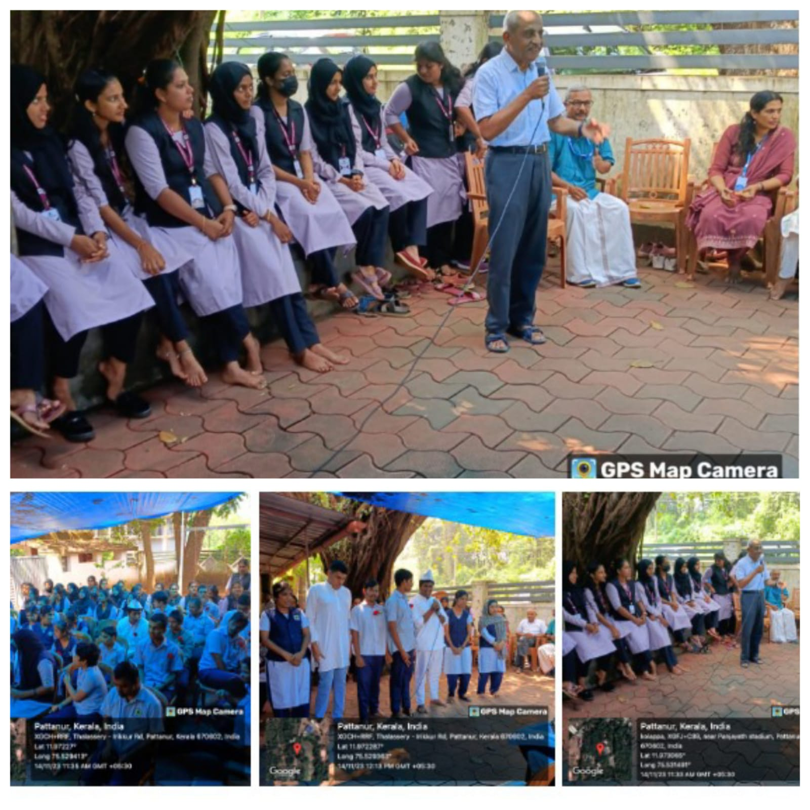

**VINJANOTHSAVAM AT GHSS CHATTUKAPPARA 02-12-2023**

On 2nd December 2023, a group of ten students from Kannur Salafi B.Ed. College had the opportunity to serve as invigilators for the Vinjanotsavam, an academic event held at GHSS Chattukappara. This experience was both educational and rewarding, as the students were entrusted with the important responsibility of overseeing the smooth conduct of the event. The atmosphere was filled with excitement and anticipation as participants and organizers prepared for a day of intellectual challenges and vibrant interactions.

The role of invigilators was a new and important experience for the students, providing them with practical exposure to the logistics of managing an event and ensuring fairness and integrity during examinations or competitions. They assisted in setting up the venue, guiding participants, and ensuring that all rules and regulations were followed. The opportunity to be part of such a prestigious event allowed them to develop essential organizational skills and a sense of responsibility.

Throughout the day, the students remained attentive and focused, ensuring that everything ran smoothly. Their efforts contributed significantly to the success of Vinjanotsavam, as they worked in harmony with the event organizers and staff. Being part of such a well-organized event gave them a glimpse into the meticulous planning and coordination required for large-scale academic events.

The experience not only helped the students develop their professional skills but also gave them an opportunity to interact with peers and educators from other institutions. They gained valuable insights into the academic world beyond the classroom and had the chance to observe how such events contribute to fostering knowledge, learning, and healthy competition among students. It was a day of growth, learning, and meaningful contributions, leaving the students with a sense of accomplishment and a deeper understanding of their roles in the educational community.

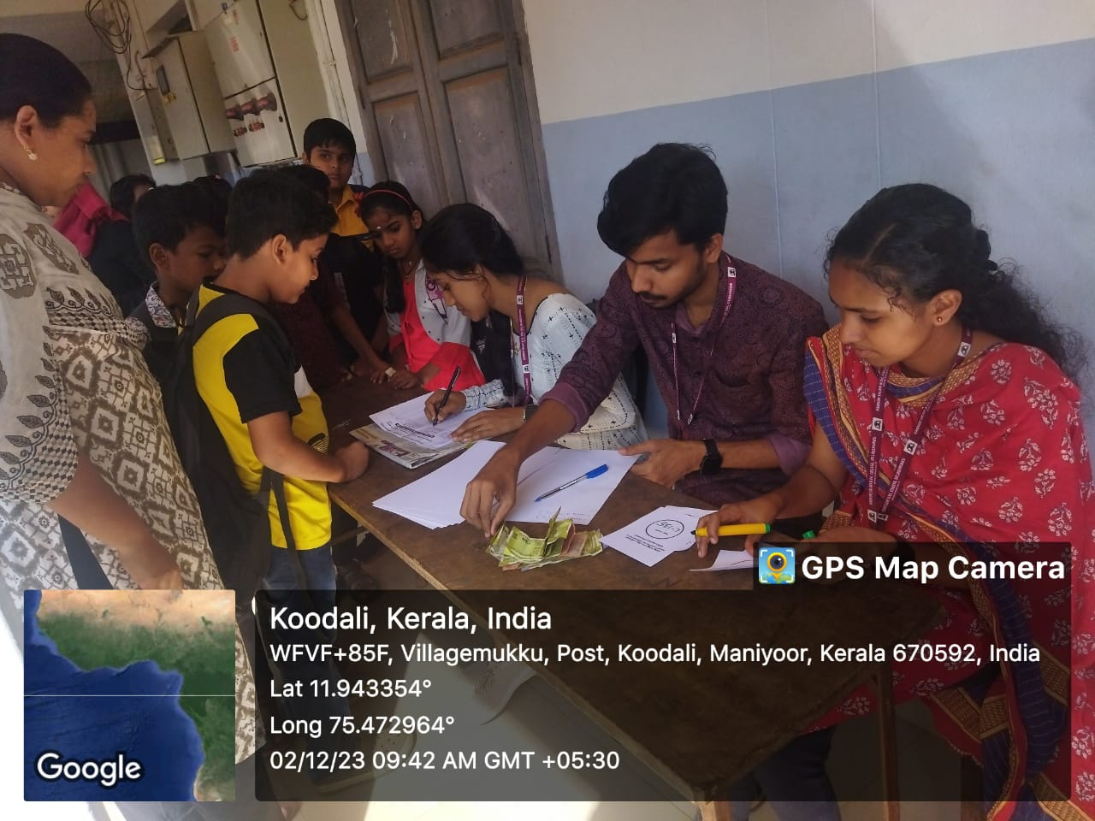VINJANOTHSAVAM AT CHATTUKAPPARA 02-12-2024

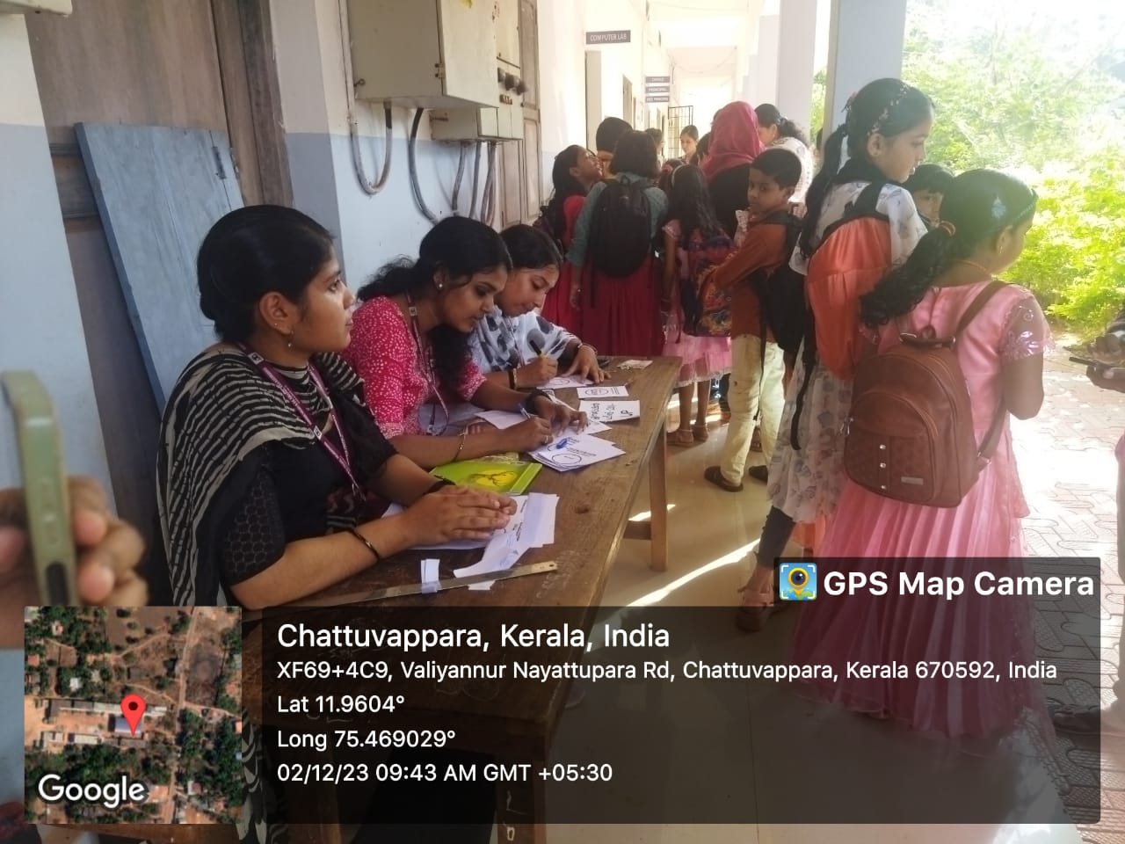

**FOOD FEST IN KANNUR SALAFI B.Ed.COLLEGE 4-12-2023**

On 14th November 2023, Kannur Salafi B.Ed. College organized a vibrant and engaging food fest that brought together students and community members to showcase their culinary talents. The event was designed not only to celebrate diverse cuisines but also to foster a sense of community participation and collaboration. Students worked tirelessly to prepare a wide variety of dishes, ranging from traditional regional foods to western delicacies, as well as an array of sweets, different types of tea, and refreshing juices. This variety ensured that the food fest catered to diverse tastes and preferences, making it an enjoyable experience for all involved.The event was inaugurated by the college principal, Dr. Naseerali MK, whose encouraging words set a positive tone for the day. He emphasized the importance of creativity and teamwork in organizing such an event, as well as the value of preserving and promoting culinary traditions while embracing new, innovative flavors. The event was not only a celebration of food but also a platform for students to demonstrate their skills in preparation and presentation.

A key feature of the food fest was the option-wise competition, where participants were judged based on the type of food they prepared. The judging panel, consisting of Sheema Teacher, the Principal of Salafi English Medium, and Ms. Sithara, evaluated the dishes on several criteria, including taste, presentation, creativity, and the use of ingredients. The competition added an exciting and competitive element to the event, encouraging participants to give their best and take pride in their culinary creations.The food fest also saw active participation from the local community, which added to the event’s success and vibrancy. Community members not only enjoyed the food but also engaged with the students, offering support and appreciation for their hard work. The inclusion of the community made the event more special, fostering a spirit of togetherness and shared celebration.

The food fest was a wonderful experience for everyone involved, offering an opportunity to explore different cuisines, bond with fellow participants, and celebrate the culinary talents of the students. It also highlighted the importance of collaboration and community involvement in organizing such events. Overall, the food fest was a resounding success, leaving everyone with a sense of accomplishment and satisfaction, as well as a deeper appreciation for the joy that food can bring to people’s lives.

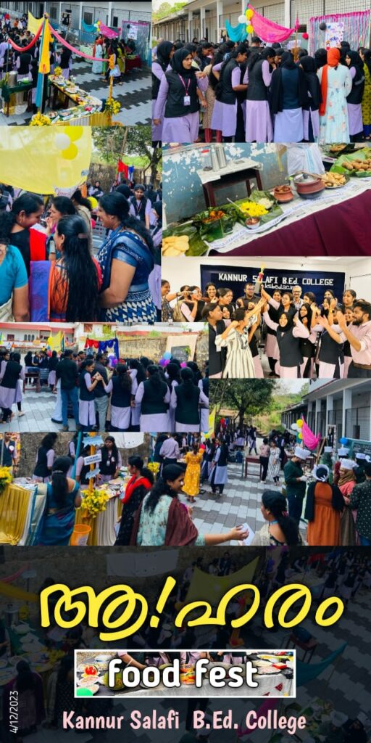

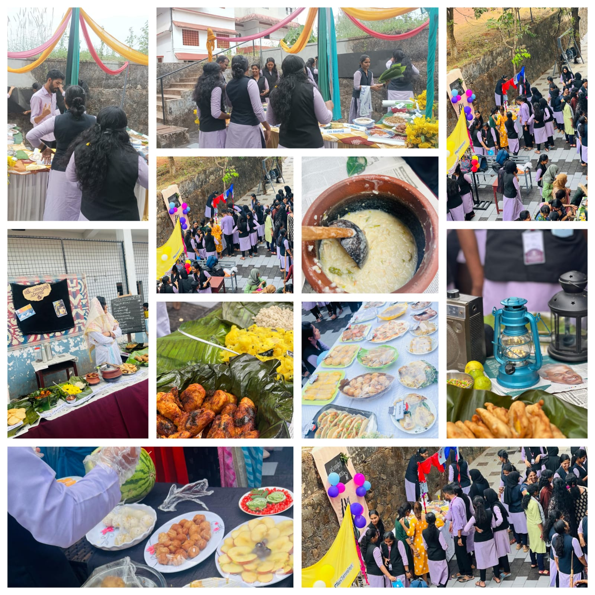FOOD FEST AT KANNUR SALAFI B.Ed.COLLEGE 04-12-2024

**CH CENTRE VISIT ON 16-02-2024**

On 13th December 2024, the students and staff of Kannur Salafi B.Ed. College embarked on a visit to the CH Centre as part of the college's commitment to best practices. This visit was aimed at extending support and care to the residents of the center, who were in need of attention and companionship. As part of the initiative, the first-year students, accompanied by their faculty, brought along snacks to share with the residents, providing them with a small but meaningful gesture of kindness. The sharing of food was not only a way to nourish the body but also to uplift the spirits of those present at the center.The visit also included a counseling session, which was guided by Ms. Sudha M, the counselor of the college. She conducted the session with great sensitivity and care, addressing the emotional and psychological needs of the residents. Ms. Sudha's expertise and compassionate approach helped create an open, supportive environment where individuals felt safe to share their thoughts and concerns. The counseling session proved to be an enriching experience for both the residents and the students, fostering a sense of community and understanding.

The students from the college had the opportunity to observe and learn from Ms. Sudha’s approach, gaining valuable insights into the importance of mental health support and the impact of professional counseling. For the students, this visit was an important step in their journey of learning and development, as they were able to witness firsthand the significance of empathy, communication, and care in providing support to others. The event not only served as a valuable educational experience but also helped foster a spirit of social responsibility and compassion among the students.Overall, the visit to the CH Centre was a meaningful and impactful experience for everyone involved. It was a day of giving, learning, and growing, as the students and staff of Kannur Salafi B.Ed. College came together to make a positive difference in the lives of those in need.

FCH CENTRE VISIT ON 16-02-2024

